Exception Handling

What is Exception?
Exception is an event that interrupts the normal flow of execution. It is a disruption during the execution of the Java program

There are two types of EXCEPTIONS:
- Compile time errors
- Runtime errors
COMPILE TIME EXCEPTION:
The exception occur during compilation time is called compile time exception.
Compile time errors can be again classified again into two types:
- Syntax Errors
- Semantic Errors
Syntax Errors Example:
- Instead of declaring int a; you mistakenly declared it as in a; for which compiler will throw an error.
- Example: You have declared a variable int a; and after some lines of code you again declare an integer as int a;. All these errors are highlighted when you compile the code.
FileNotFoundExpection, ClassNotFoundException etc.
Run Time Exception:
The exception occur during run time is called compile time exception.
It is any event that interrupts the normal flow of program execution.
Example for exceptions
Nullpointer exception,
NoSuchElementFound exception
StaleElementReferenceException
// Before clicking some thing happened and DOM has changed due to page refresh, or element is removed and re-added
NoSuchElementException - Thrown by WebDriver.findElement(By by) and WebElement.findElement(By by) - When ever the element is not found in DOM, you will get this exception.
StaleElementReferenceException - This Exception occurs when driver is trying to perform action on the element which is no longer exists or not valid.

NoSuchWindowException, TimeoutException

Why do we need Exception?
Suppose you have coded a program to access the server. Things worked fine while you were developing the code.
During the actual production run, the server is down. When your program tried to access it, an exception is raised.

How to Handle Exception
blaming your code failure on environmental issues is not a solution. You need a Robust Programming, which takes care of exceptional situations. Such code is known as Exception Handler.

In our example,
good exception handling would be, when the server is down, connect to the backup server.
To implement this, enter your code to connect to the server (Using traditional if and else conditions).
You will check if the server is down. If yes, write the code to connect to the backup server.

class connect{
if(Server Up){
// code to connect to server
}
else{
// code to connect to BACKUP server
}
}

Exception:
Exception is an event that disrupts the normal flow of the program. It is an object
which is thrown at runtime. It does􀅶’t stops 􀇇our progra􀅵 from running.
1. Checked Exception (Compile time)
2. Unchecked Exception (Run time)
Exception Handling:
Exception Handling is a mechanism to handle runtime errors such as
ClassNotFoundException,IOException, ArrayIndexOutOfBoundException etc.
Error:
Error is extend from Throwable class and it stops the program to continue a􀅶d 􀇁e 􀄐a􀅶’t
handle it.
E.g. outofMemoryError, StackOverFlowError

Try Catch Block
Java provides an inbuilt exceptional handling.

- The normal code goes into a TRY block.
- The exception handling code goes into the CATCH block

Try – is the block where your real logic or implementation exists.
• Catch – is the block will catch when exception occurs at run/compile
time.
In our example, TRY block will contain the code to connect to the server. CATCH block will contain the code to connect to the backup server.
In case the server is up, the code in the CATCH block will be ignored. In case the server is down, an exception is raised, and the code in catch block will be executed.

try{
statement(s)
}
catch (exceptiontype name){
statement(s)
}

• Finally – is the block irrespective of exception will execute always
Example taking screen shot , its passed or failed irrespective of condition we will take
How finally works in exception handling

Syntax of try catch and finally

try{
}catch(Team – Lead - Exception e1){
}catch(Project – Manager - Exception e2){ Exception class should catch from low to
high like in this example
}
…..
…..
catch(CEO - Exception en){
}finally{
}

try {
Select dd = new Select(ele);
dd.selectByValue(value);
reportStep("drop down sleceted by visible text", "pass");

} catch (Exception e) {
System.out.println("exception has occured");
reportStep("drop down NOT sleceted by visible text", "fail");
throw new RuntimeException();
}finally
{
takeSnap();
}

public static void main(String[] args) throws FileNotFoundException

Java Exception class Hierarchy
After one catch statement executes, the others are bypassed, and execution continues after the try/catch block. The nested catch blocks follow Exception hierarchy.
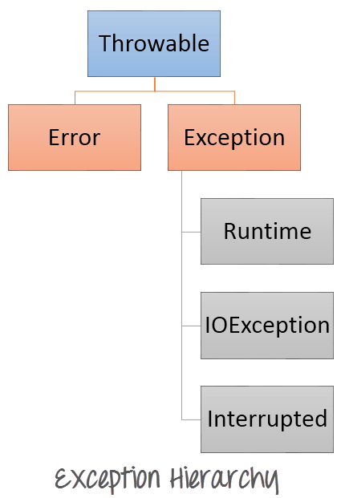

How exception handling in selenium

In selenium all the exception are RUN TIME EXCEPTON􀍟
• Whenever you are handling with driver object, web element it
always recommended to handle the exception with try , catch and
finally.
• Few e.g. of selenium exception
- No such element found exception
Selenium Exception
java.lang.Object
– java.lang.Throwable
- java.lang.Exception
– java.lang.RuntimeException
- org.openqa.selenium.WebDriverException
– org.openqa.selenium.NotFoundException
-org.openqa.selenium.NoSuchElementException
What is throws in Exception Handling
Throws is a keyword will be declared in method level
• When there is a compile time exception occurs and you don’t want to handle it the same class / method use throws
• Throws will throw the exception to calling method, where you are forced to handle with either try catch or throws
• If we throws exception no need to write try, catch and finally blocks
• E.g.. FileNotFound Exception, Thread.sleep()
• Syntax:
• public void getName(String employeeName) throws FileNotFoundException, Exception {
// logic
}
Note: You can throws more than one Exception class, but all should be catch from calling method

Difference between throw and throws in Exception handling.

Throws | Throw
Used in method level signature | Used inside try or catch block, even  without try catch
Throws to calling method | Throw to specified exception class
Your program continues run even there  is exception occurs | Your program stops and exit from the  program
Syntax: method throws Exceptoin {  // method implementation  } | Syntax: throw new Exception class  Constructor();

Debugging
is a in build feature coming with eclipse
and net beans, to debug your code at run time..
Features :
• Pass your code at break point
• Can read / change the values of object at break
point
• Can watch the variable
Key Functionality
F5 Step into
F6 Next line of code
F8 Next Break point
How to run the code in Debug mode

Right click on java file, choose Debug As option rather Run As option
Other tabs inDebug window
Without short cuts also we can
debug our code
- Run time we can read / modify the
values of variable in Variable tab

NoSuchE lementFound
NoSuchFrameFound
NoSuchWebElement
NoAlertPresent

Why NoAlertPresent why not NoAlertFound
Because we can handle multiple frames elements web element at a time, but we can handle single alert at atime. That’s why this difference.

